
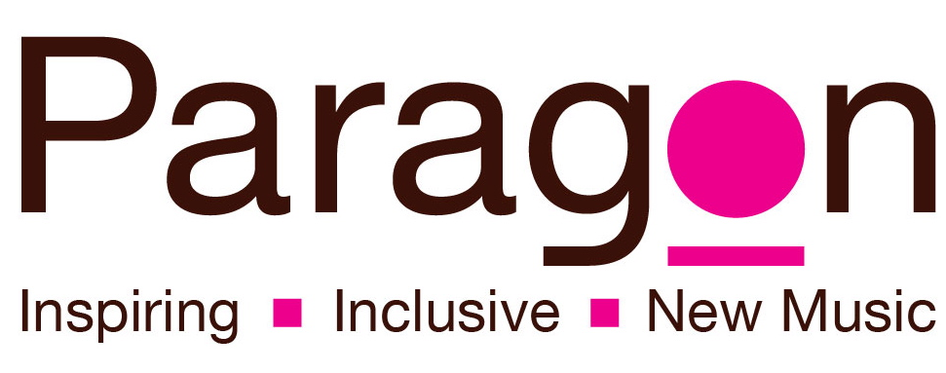

Friends of Paragon
Paragon uses music and dance as a tool to transform the lives of young people and adults who are disadvantaged and isolated. By becoming a “Friend of Paragon”, you will be helping us continue to deliver and develop our inclusive music and dance activities for people across Scotland and abroad. You will be helping us to transform lives!

“To see these people, each with their own challenges, come together, play music together, encourage and support each other, laugh and have fun is truly touching and inspirational.” (parent)

Paragon’s vision is a society where equality and inclusion are the pillars of learning and personal growth: using music and dance to create environments where individuals can truly flourish together. By setting up a standing order for as little as £2 per month, you can ensure that our work continues to reach people who regularly face insurmountable barriers to participating in the arts.

We are extremely grateful to all of our Friends of Paragon and are delighted to show our appreciation through:

- Free or discounted entry into our concerts and events
- Your name acknowledged on our website (you can also remain anonymous)
- Your very own Paragon badge!

Please complete the form over the page to sign up and start making a difference today!

I want to be a Friend of Paragon!

Name: __________________________________________________________________
Address: __________________________________________________________________
_____________________________________ Postcode: ____________________
Telephone: ____________________ Email: ________________________________________
Gift Aid: Using Gift Aid means that for every pound you give, we can claim an extra 25p from the Inland Revenue, making your donation go further. Please tick below to enable Paragon Music to claim Gift Aid on your donation.
 I would like Paragon Music to treat all donations that I make from the date of this declaration as tax-effective under the Gift Aid scheme until further notice.

Standing Order
To: ___________________________________________________________________________
______________________________________________________________________________
___________________________ (name and address of your bank)
Please pay the sum of (delete those that do not apply)
£2 / £5 / £10 / other amount _______ (please state) per month, commencing on ___/___/______ (day/month/year) until further notice. Please allow at least 2 weeks from sending in your form until the first payment date.
To: Clydesdale Bank, 30 St Vincent Place, Glasgow, G1 2HL
Acc. name: Paragon Ensemble Ltd. Acc. no: 40446756 Sort Code: 82-20-00
From my account: _____________________________________________________________
Account number: _______________________ Sort Code: ___________________________

Signed: _______________________________________________________________________
Date: _________________________________
Thank you for your support! Please return this completed form to: Paragon Music, 350 Sauchiehall Street, Glasgow, G2 3JD or admin@paragon-music.org. For any enquiries, please call 0141 354 0234.

